(Capstone) Shoply.com

Jonathan Hollingsworth

Springboard

# Overview

Create a Mock Online Store Application where Users can fill their Cart with various Items from the page and proceed to a Mock Checkout.

# Goals

1. Develop and Deploy an Application that can Imitate the functionality of an online store
2. Create a Database that the Application can use to update Important information
3. Create an accessible UI/UX

# Specifications

1. Technology used for the Project:
   1. This will be a Full-Stack Application using NodeJS and ReactJS
2. Focus:
   1. This Application will be evenly focused as a Full-Stack Application
3. What is it?:
   1. The application will be a website that may have mobile accessible UI/UX
4. Goal:
   1. The website should allow the user to make it easy to find what they are looking for and purchase it
5. Demographic:
   1. This app will be designed with Users who are Young-Adults or older due to the nature of this type of application
6. Data:
   1. The Application will use a hand-made API and Database
   2. The Database will include data for Users, Carts, Whishlists, and Items
7. Outline:
   1. Schema: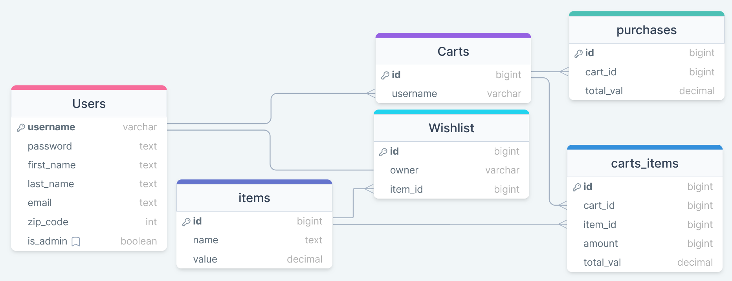
      1. Users: username, password, first_name, last_name, email, zip_code (for delivery)(may not be needed), is_admin
      2. Items: id, name, value
      3. Carts: id, owner(user.username)
      4. Wishlist: id, owner(user.username), item_id(items.id)
      5. Carts_Items: id, cart_id(carts.id), item_id(items.id), amount, total_val
      6. Purchases: id, cart_id(carts.id), total_val
   2. API Issues:
      1. It is not guaranteed that the data management will be efficient
      2. Figuring out all required endpoints will be complicated
   3. Sensitive Information:
      1. Password, Email, and Zip Code
   4. Functionality:
      1. Users can register or log in
      2. Users can add items to their cart to purchase
      3. Users can add items to their wishlist so they can quickly find and purchase it at a later date
      4. Users can purchase the items within their cart
   5. More Than CRUD:
      1. Users can save items to their wishlist for future reference in case they want to purchase it at a later date (This would also be useful for items that are out-of-stock)